Daniel Sterling

Aaron Suarez

Ivelisse Montero

**Genre and Platform Sales Across Regions from 1980-2005**

Thesis: Our study will analyze the sales performance of video games across genres and platforms through different regions, identifying shifts in genre and platform popularity and their correlation with the regions they are sold in.

Platform Sales: What platforms have the highest sales and what platforms are most prominent in each region? To find this information we grouped the sales by platforms that were available in our data set. After doing so we created individual tables for global sales as well as each region available. Global Sales showed a lot of consistency with North America, Europe, and Other Regions. PlayStation 2 dominated sales with both PlayStation 1 and PlayStation 3 achieving similar sales, all being within the top 6 consoles. Wii and Xbox360 also had high sales globally, keeping up with the PlayStation 3 sales. The only handheld console in our top 6 was the Nintendo DS. None of the other Consoles had noteworthy sales. Japan Sales showed a major difference with the Xbox 360 barely selling and being nowhere near Japan’s top consoles. This is likely due to Microsoft not being a Japanese based company. (Reference pages: 3-8)

Genre Sales: What genres have the highest sales and what genres are the most prominent in each region? We used the same logic when analyzing Genre Sales. First grouping sales by genres, then creating individual tables for our regions. Just like with platform sales we notice similar trends between Global Sales and every region besides Japan. Action, Shooter, and Sports games were our top 3 performing genres globally. In Japan, Action and Sports games still dominated sales, however there is a clear distain for Shooter games. There is also a separate category that has almost no sales globally, but Japan managed to make up for it. Role-Playing games were the top performing genre in Japan, even above Action and Sports titles. Many RPGs originate in Japan, so there is a clear love for the genre within the country. (Reference pages: 9-14)

Major Contributions to Genre Sales: What were the three main genres seen in our data set and what countries contributed most to these genres? Initially we wanted to find out what countries were contributing most to Genre sales, however after visualizing our data set, we can see that all the genres are consistent with the population of the individual regions. Action, Sports, and Shooters were mostly consistent in all the countries, with only Japan’s shooter sales being an inconsistency. (Reference pages: 15-19)

Correlation Between Years and Sales: Does the year a game is released affect its sales and what were the peak years for video game sales? As time has moved, overall, gaming has become more and more popular. From 1980-1995, gaming had a small but steady increase in sales. However, from 1995-2005, there is an incredibly increase in sales. Gaming popularity drastically increased during this time frame, with its peak being in the final year, 2005. Factors like populations increasing, as well as gaming becoming more and more successful, likely affect this information. It is clear from our line graph and our heat map that gaming was at its peak from 2000 to 2005. (Reference pages: 20-23)

Call to Action: Based of our Analysis of the Data Set we have concluded that if a new game were to included elements of Action, Sports, and Shooter games, while also ensuring that they focus marketing on North America and Europe, that game would have the best foundation for success.

Bias: The major bias of our data set is platforms. Certain games could have likely found more success had they been made available on other Platforms. This is the case with Japan's Platform Sales.

Limitation: The major limitation to our data set is not having indications for a game being part of a long running series. This would heavily affect the popularity of a release.

Future Work: Companies like Microsoft would benefit from looking at sales in Japan, such as Role-Playing Games (RPGs), which would increase their overall sales output. America and Europe both have identical sales trends for both Platforms and Genres, so marketing similarly in both of those regions will benefit game developers.

**Data Visualizations:**

Platform Sales:

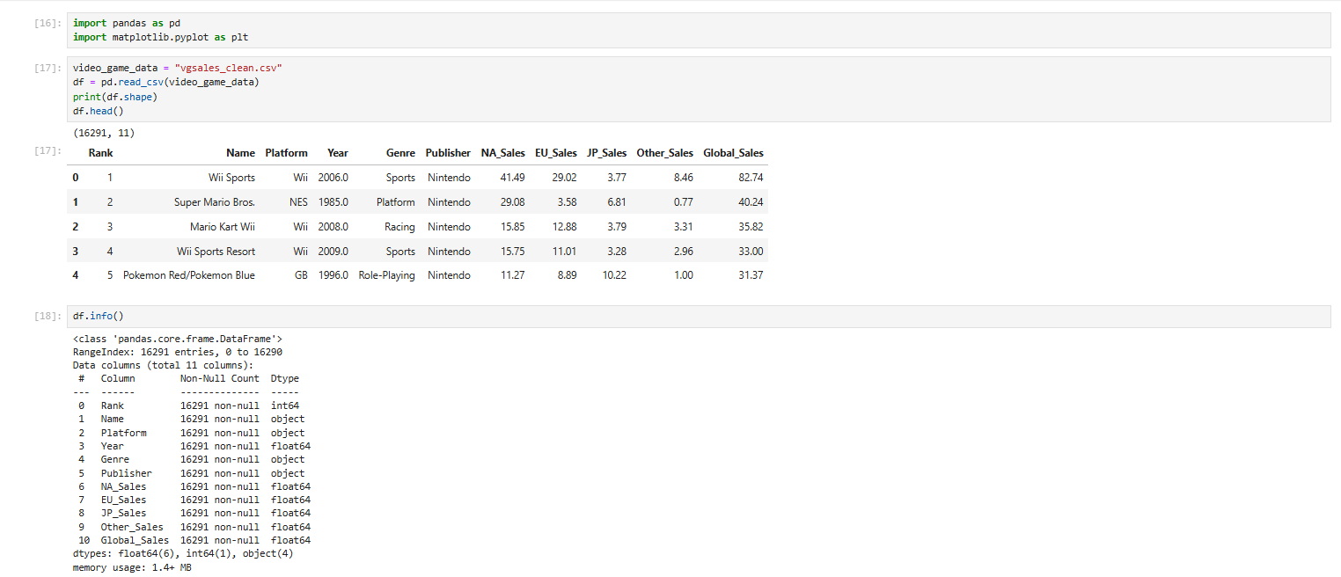

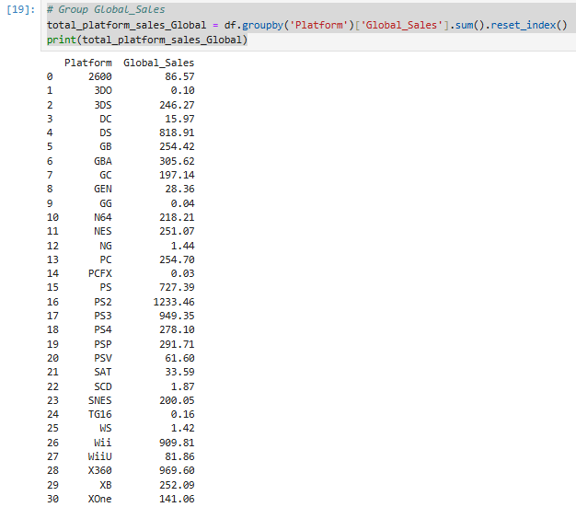

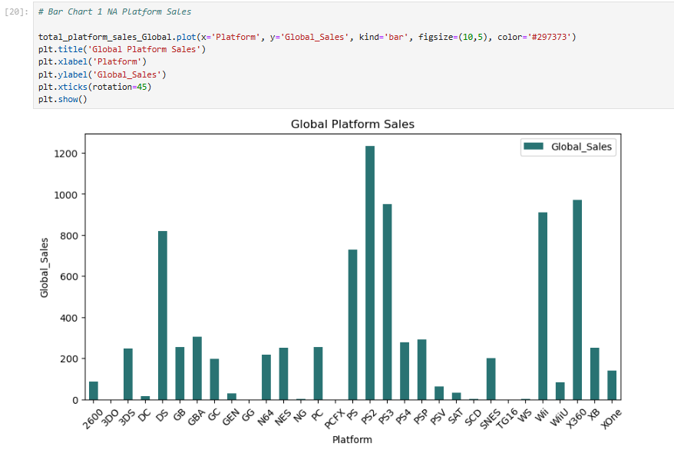

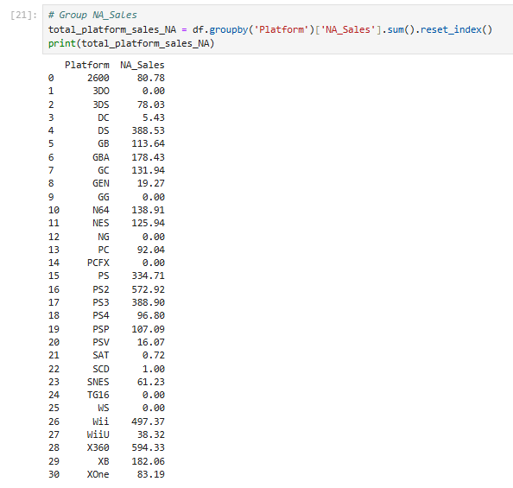

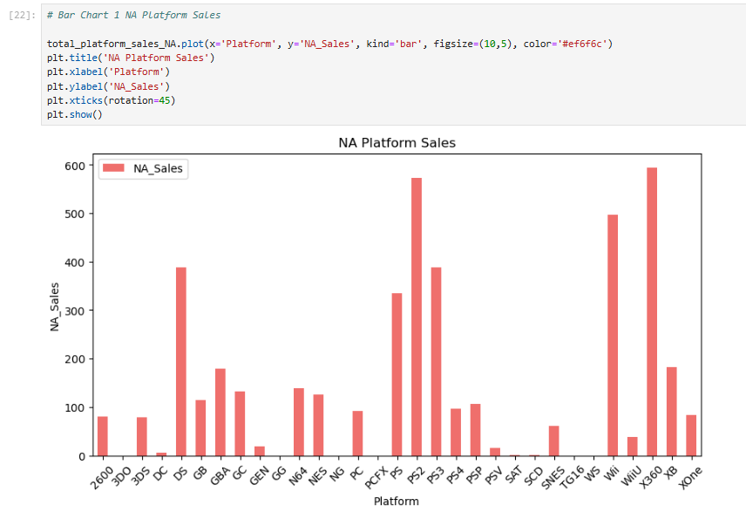

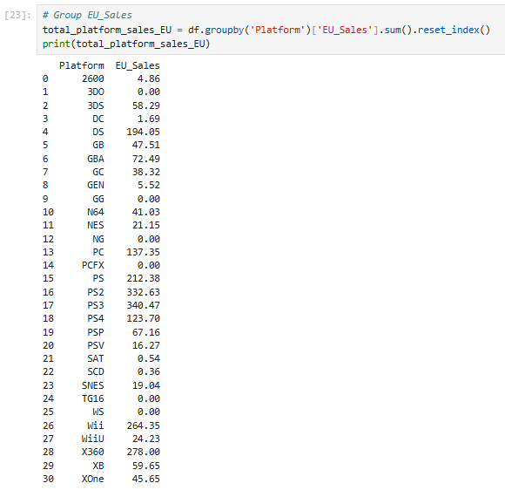

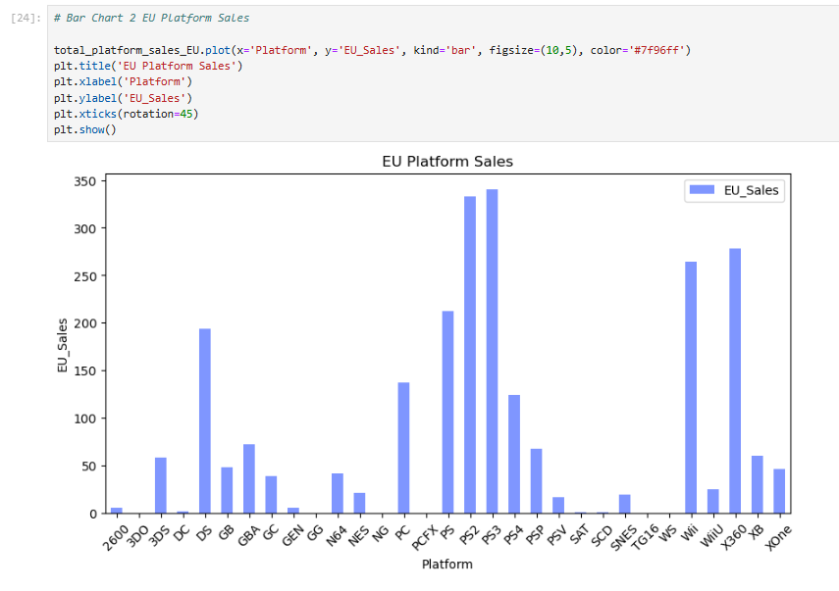

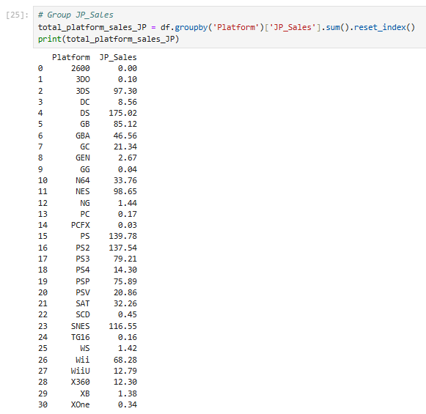

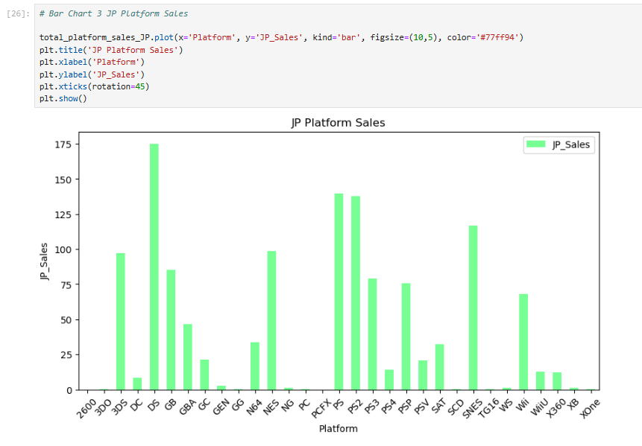

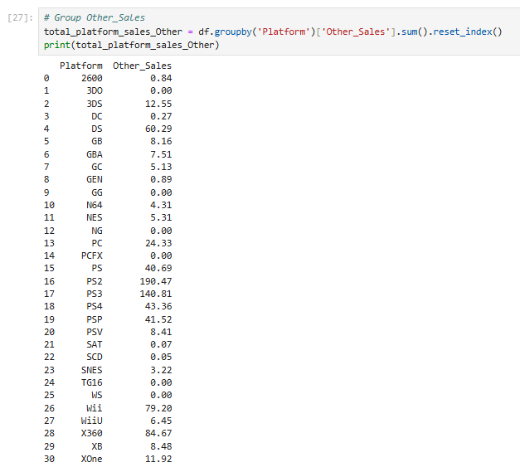

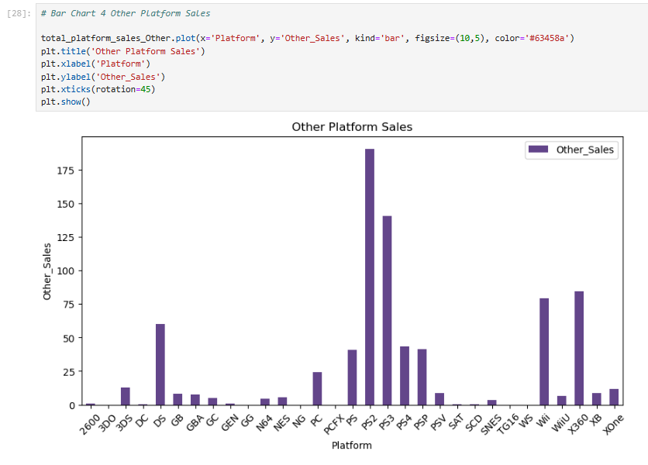

Genre Sales:

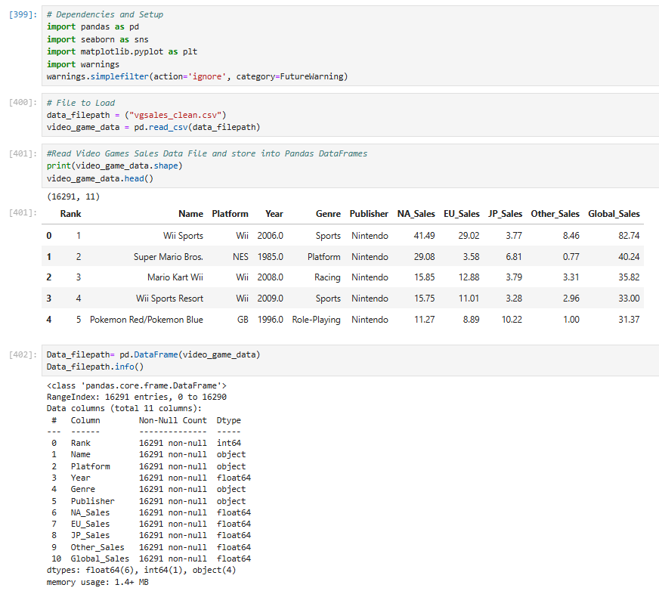

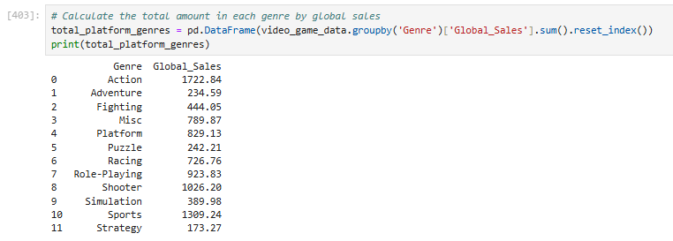

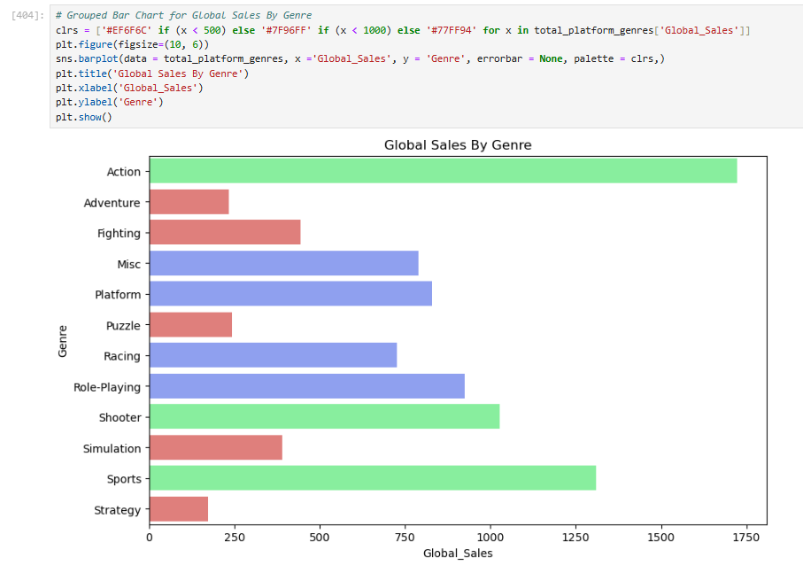

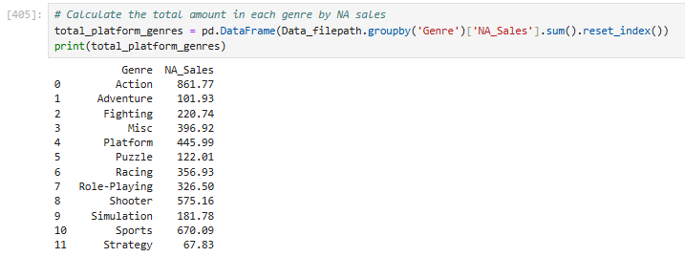

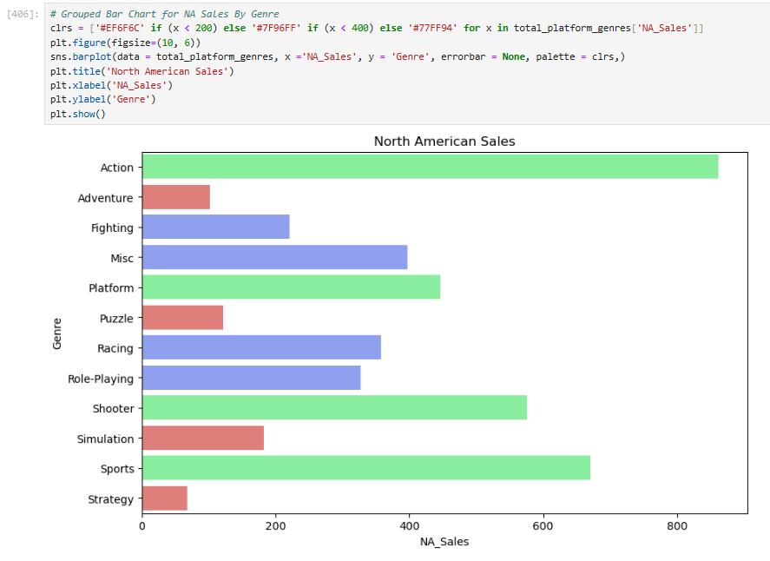

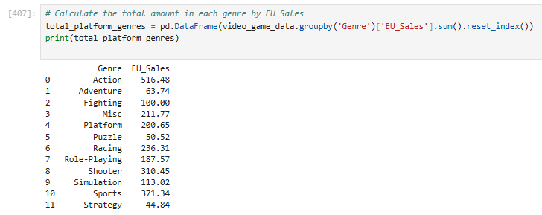

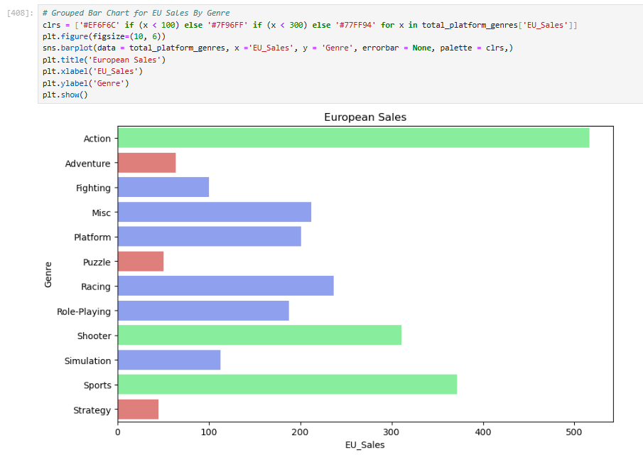

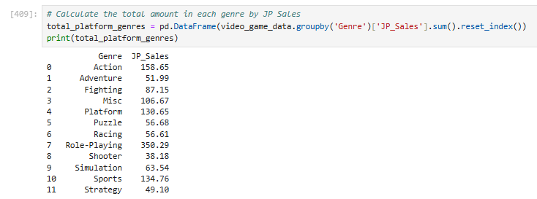

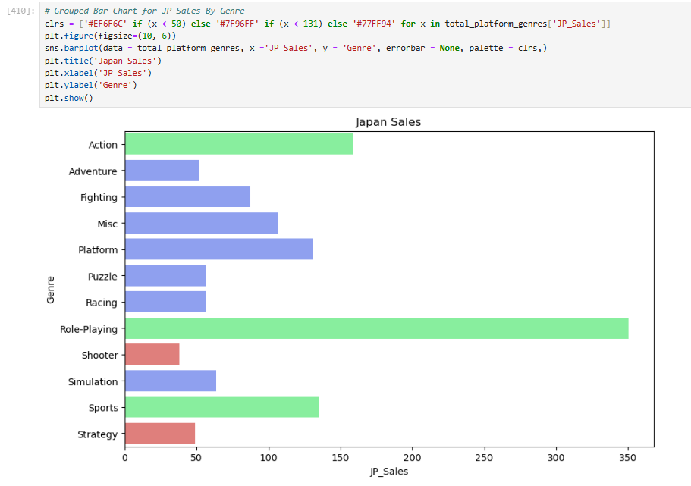

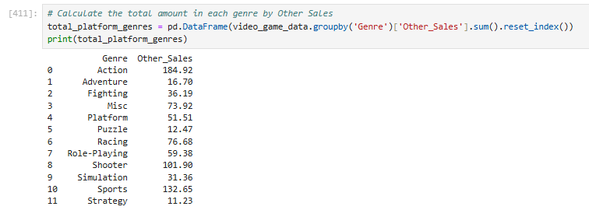

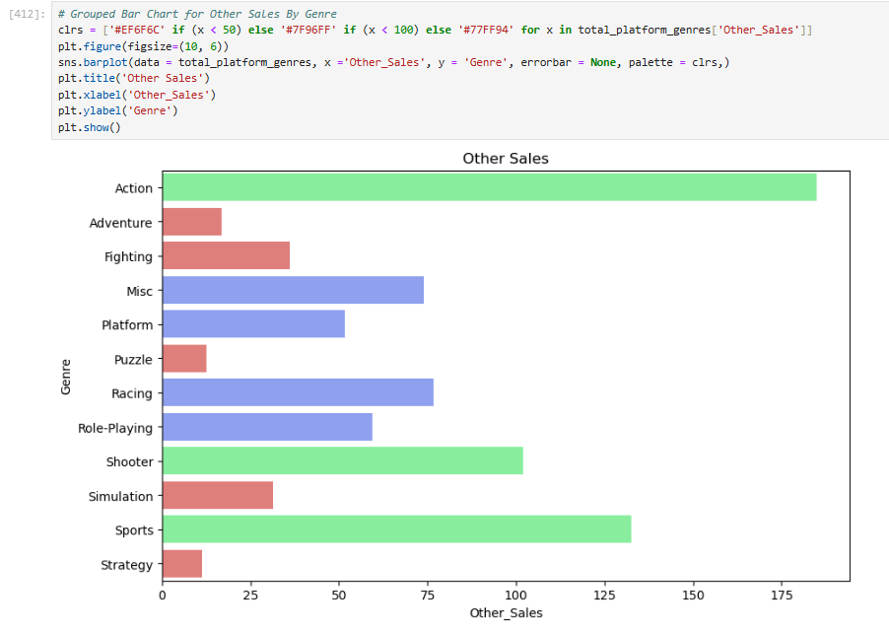

Major Contributions to Genre Sales:

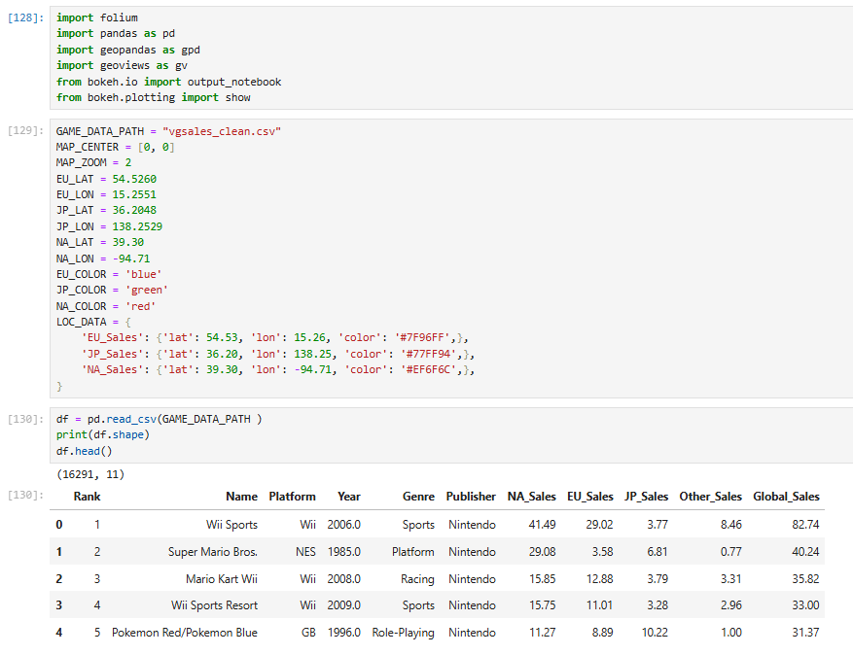

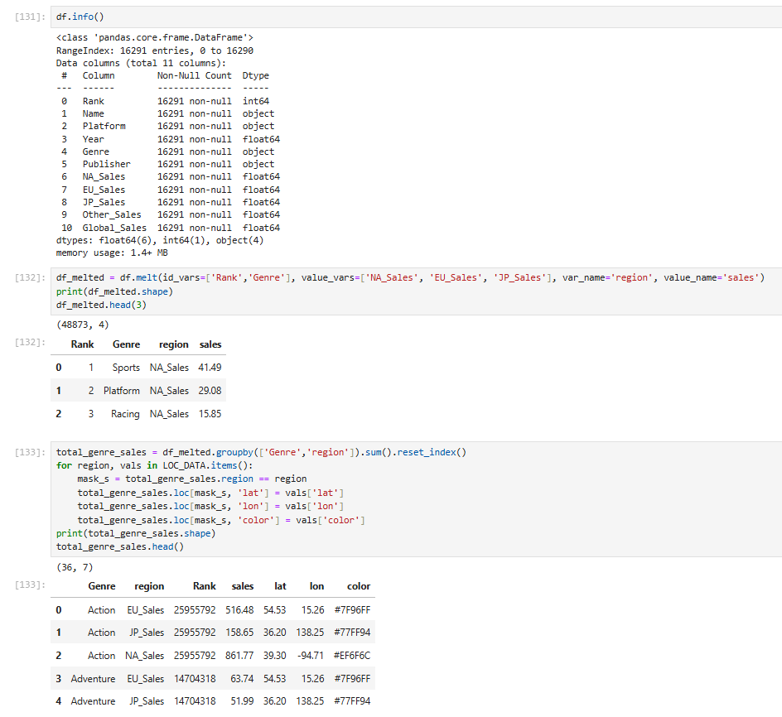

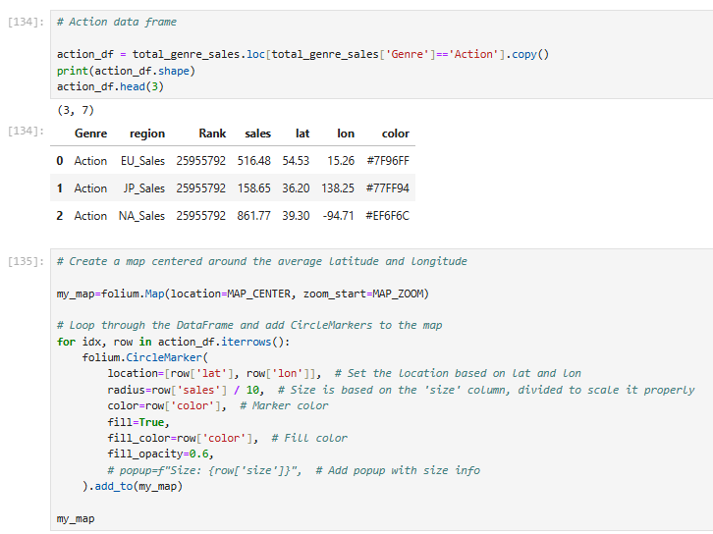

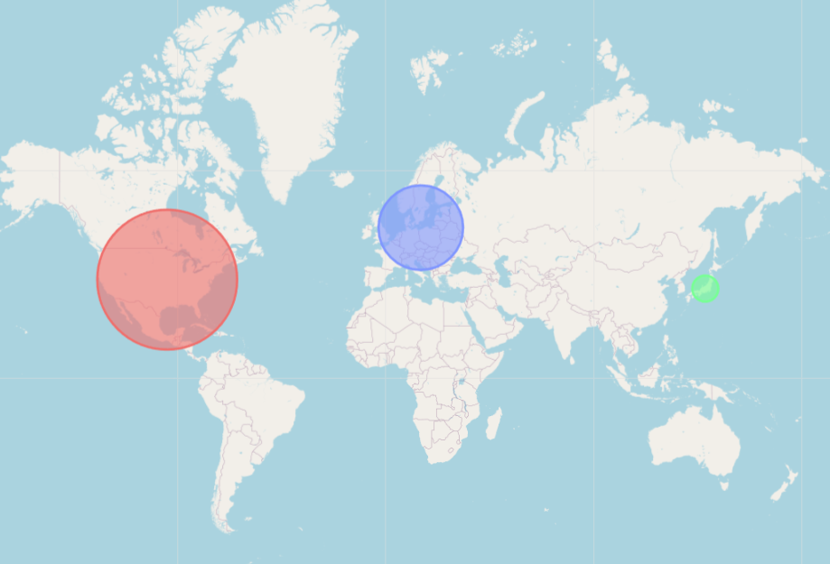

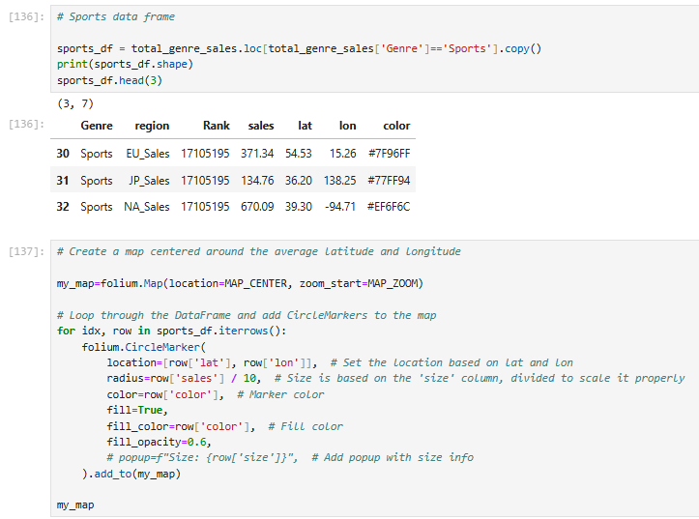

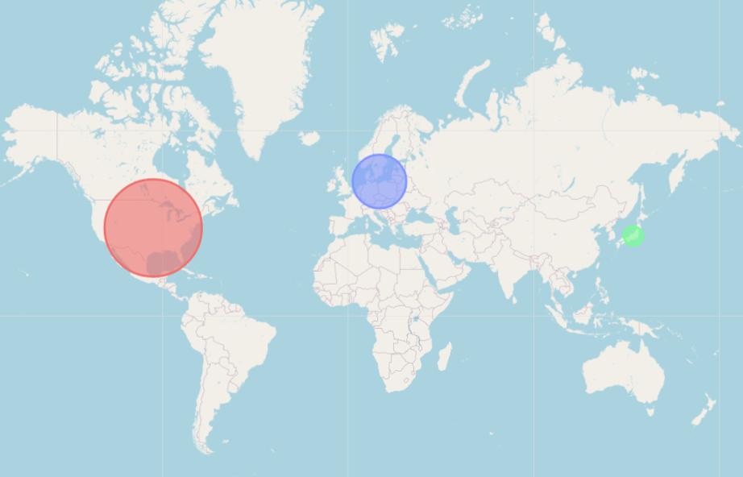

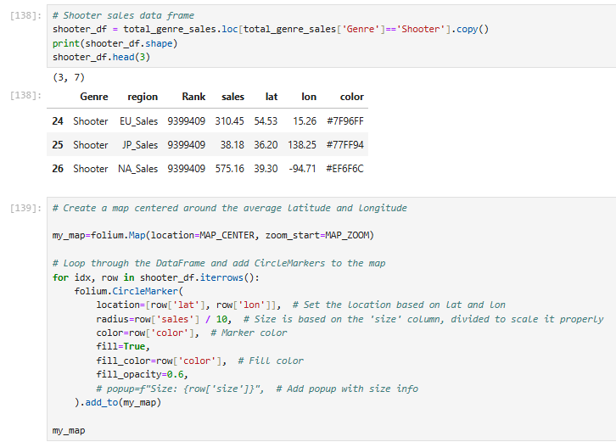

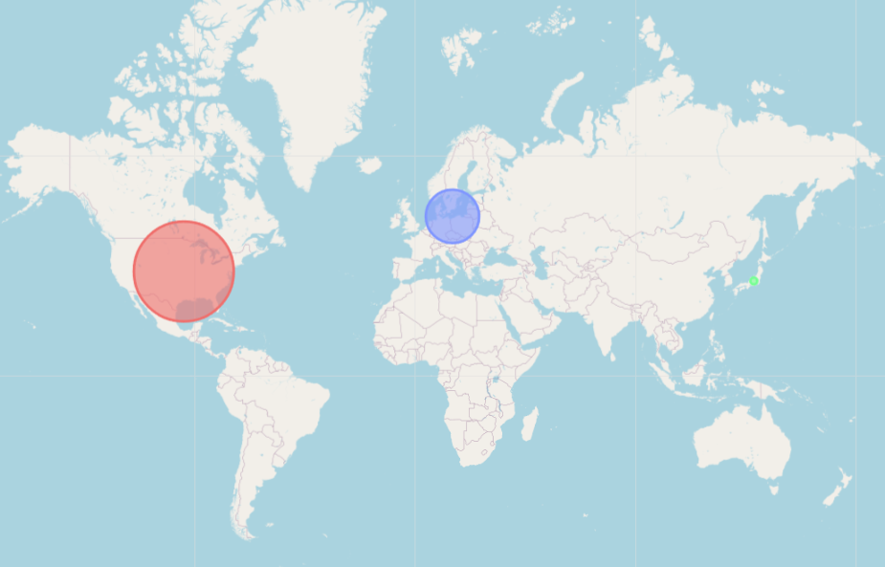

Correlation Between Years and Sales:

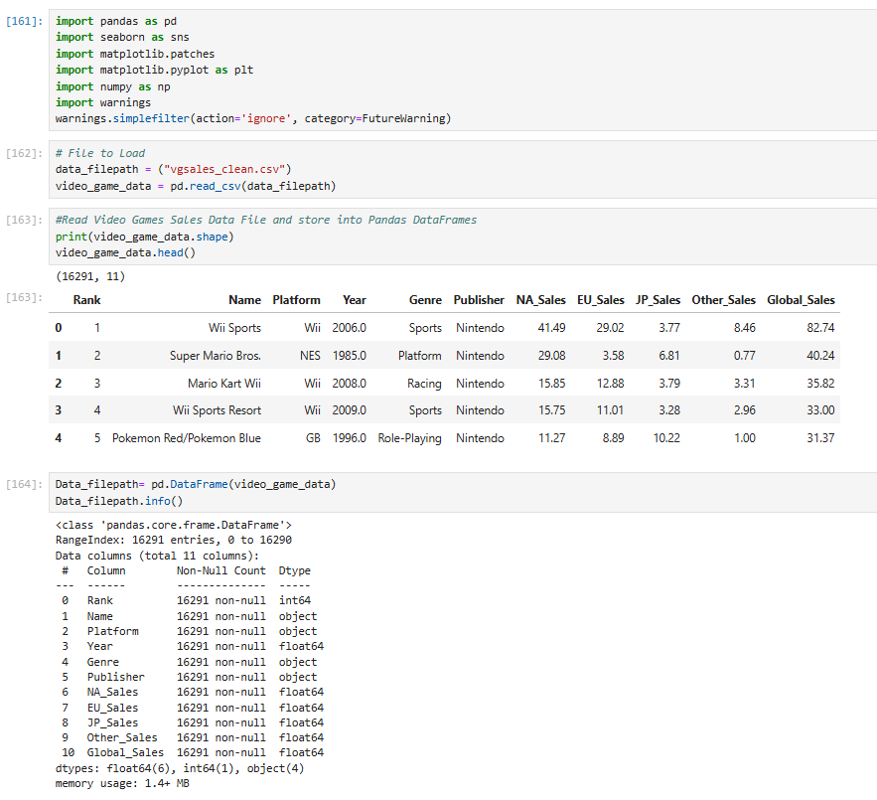

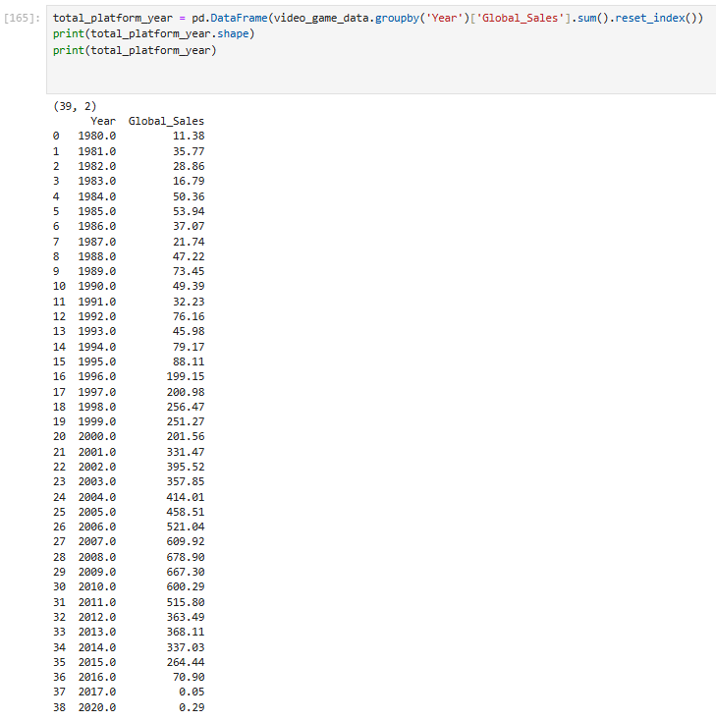

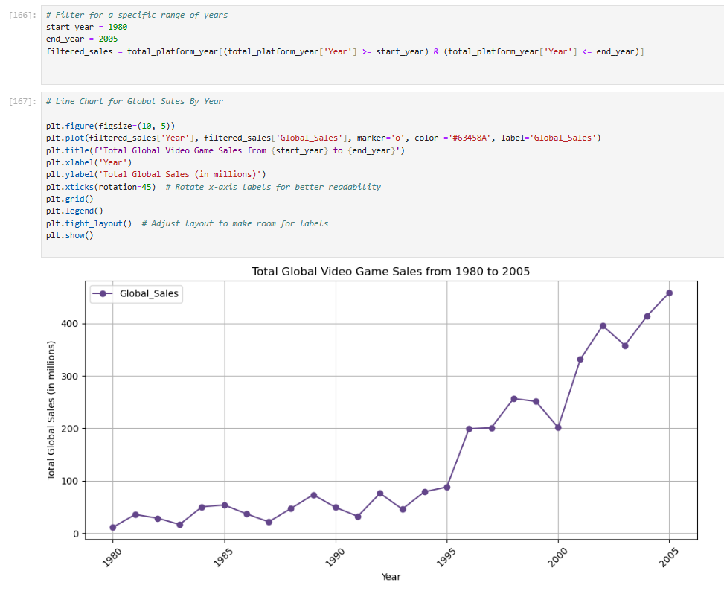

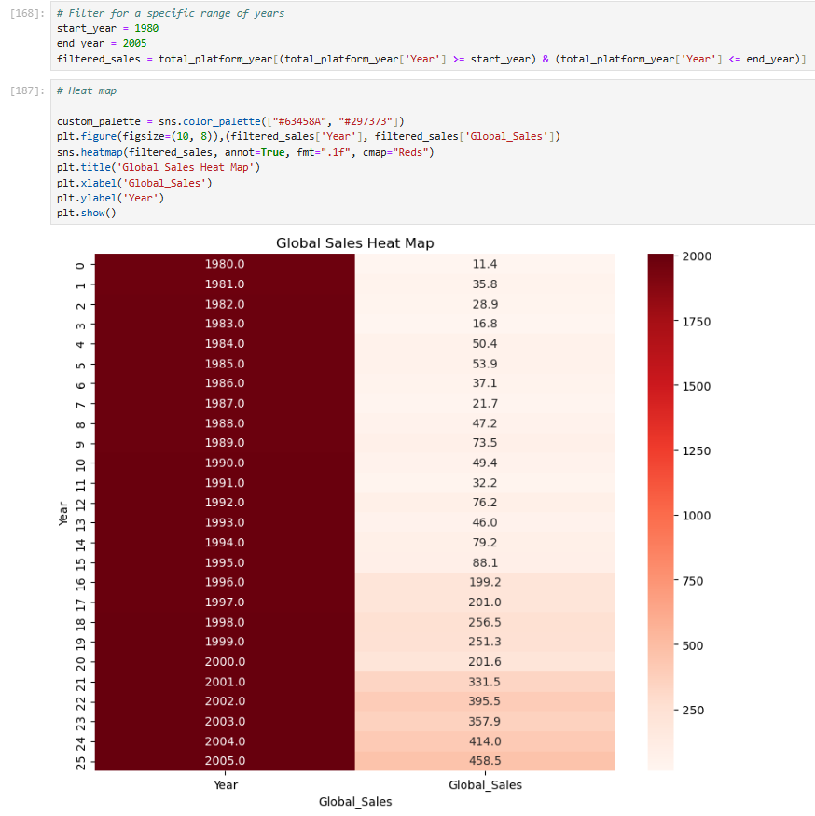

Work Cited:

Upadorprofzs. “Eda - Video Game Sales.” *Kaggle*, Kaggle, 21 July 2020, [www.kaggle.com/code/upadorprofzs/eda-video-game-sales](http://www.kaggle.com/code/upadorprofzs/eda-video-game-sales).

“Chatgpt.” ChatGPT, chatgpt.com/. Accessed 13 Dec. 2024,

<https://chatgpt.com>.